CSS TEMPLATE

Template-1 code=
HTML
<!DOCTYPE html>
<html lang="en">
<head>
<meta charset="UTF-8">
<meta name="viewport" content="width=device-width, initial-scale=1.0">
<title>Simple CSS Template</title>
<link rel="stylesheet" href="css table.css">
</head>
<body>
<header>
<h1>Simple CSS Template</h1>
</header>
<nav>
<ul>
<li><a href="#">Home</a></li>
<li><a href="#">About</a></li>
<li><a href="#">Products</a></li>
<li><a href="#">Services</a></li>
<li><a href="#">Design</a></li>
<li><a href="#">Contact</a></li>
</ul>
</nav>
<div class="container">
<aside class="sidebar">
<h3>Links</h3>
<ul>
<li><a href="#">SEO</a></li>
<li><a href="#">Web design</a></li>
<li><a href="#">Web development</a></li>
<li><a href="#">Content creation</a></li>
<li><a href="#">Internet Marketing</a></li>
<li><a href="#">XHTML Templates</a></li>
<li><a href="#">CSS Templates</a></li>
</ul>
</aside>
<section class="content">
<h2>This is a title</h2>
<p>Lorem ipsum dolor, sit amet consectetur adipisicing elit. Facilis perspiciatis tempora doloremque delectus, consequatur minus cumque sit distinctio ullam optio dolore asperiores labore molestiae dolorem debitis. Asperiores, iste quos at eligendi labore aperiam, illum dolore, voluptate expedita soluta possimus officia.
</p>
<p>Lorem ipsum, dolor sit amet consectetur adipisicing elit. Praesentium harum libero, possimus hic, aspernatur cumque amet perferendis cum ratione ipsum facilis eaque modi. Dolor ipsa placeat aliquam sit, iure in! Eligendi nostrum vero sint numquam harum enim consectetur odio alias.
</p>
<p>Lorem ipsum dolor, sit amet consectetur adipisicing elit. Cumque reiciendis officiis iste eius, natus eaque saepe molestias nisi, tempora facilis at architecto eos necessitatibus quisquam!</p>
</section>
</div>
</body>
</html>

CSS *{
margin: 0;
padding: 0;
box-sizing: border-box;
}
body {
font-family: Arial, sans-serif;
background-color: #f0f0f0;
}
header {
background-color: #cc5500;
color: white;
text-align: center;
padding: 20px 0;
}
header h1 {
margin: 0;
font-size: 50px;
}
nav {
background-color: #cc5500;
padding: 10px;
text-align: center;
}
nav ul {
list-style-type: none;
}
nav ul li {
display: inline;
margin: 0 15px;
}
nav ul li a {
color: white;
text-decoration: none;
font-size: 18px;
}
.container {
display: flex;
justify-content: space-between;
padding: 20px;
}
.sidebar {
background-color: #0044cc;
width: 25%;
padding: 20px;
color: white;
box-shadow: 0 2px 10px rgba(0, 0, 0, 0.2);
}
.sidebar h3 {
font-size: 22px;
margin-bottom: 10px;
}
.sidebar ul {
list-style-type: none;
padding-left: 0;
}
.sidebar ul li {
margin: 10px 0;
}
.sidebar ul li a {
color: white;
text-decoration: none;
background-color: #0033aa;
display: block;
padding: 10px;
border-radius: 5px;
}
.sidebar ul li a:hover {
background-color: #002288;
}
.content {
background-color: white;
width: 70%;
padding: 20px;
box-shadow: 0 2px 10px rgba(0, 0, 0, 0.2);
}
.content h2 {
font-size: 28px;
margin-bottom: 20px;
}
.content p {
margin-bottom: 20px;
line-height: 1.6;
}

OutPut

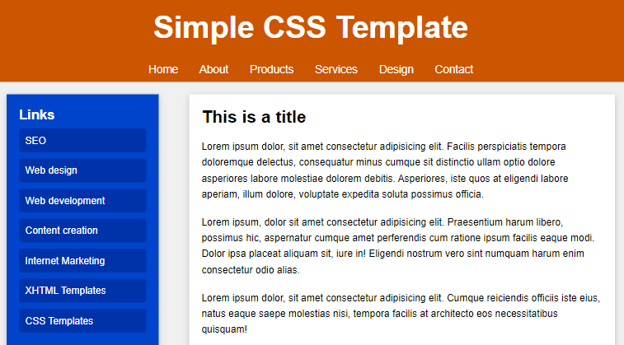

Template-2 code=

